Advanced Angular Application Development and Deployment Across Two Virtual Machines (VMs) Using Nexus Repository and Nginx

1. Project Overview
This project demonstrates a three-server architecture used for building, storing, and deploying an application manually using different servers.
The architecture is designed to separate build, artifact storage, and deployment activities across different servers for better management and organization.
The workflow includes:
- Cloning source code from Git repository
- Building the application using Node.js and NPM
- Creating build artifacts
- Storing the build artifact in Nexus Repository
- Downloading and deploying the build artifact to the deployment server

2. Architecture Overview
Three Server Architecture

Server 1 – Build Server
The Build Server is responsible for:
- Cloning the source code from Git
- Installing dependencies
- Building the application
- Creating deployment artifacts
- Uploading the artifact to Nexus Repository

Server 2 – Nexus Repository Server
The Nexus Server acts as an artifact repository.
Responsibilities:
- Storing build artifacts
- Managing version control of artifacts
- Providing centralized artifact access
- Allowing deployment server to download build packages

Server 3 – Deployment Server
The Deployment Server is responsible for:
- Downloading build artifacts from Nexus
- Extracting the application package
- Deploying the application
- Running the application in the target environment

3. Tools and Technologies Used
Tool / Technology | Purpose
Git | Source Code Management
Node.js  NPM | JavaScript Runtime Environment  Package Management
Angular / React / Node Application | Application Build
Nexus Repository | Artifact Storage
Linux Server | Hosting Environment
Curl | Uploading artifacts to Nexus
Wget | Downloading artifacts from Nexus
Zip | Packaging build files

4. Manual Build and Deployment Workflow
Step-by-Step Process
Step 1: Clone Source Code from Git
The source code is cloned from the Git repository into the Build Server.
Command
git clone https://github.com/Ai-TechNov/AngularCalculator.git
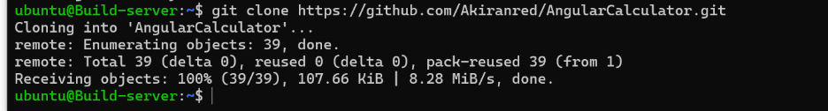

Step 2: Install Node.js and NPM
Node.js and NPM are installed on the Build Server.
Install Node.js
sudo apt update
sudo apt install nodejs -y
Install NPM
sudo apt install npm -y
Verify Installation
node -v
npm -v

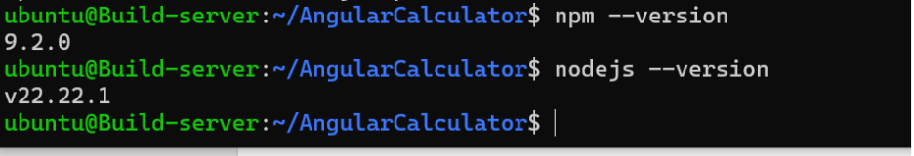

Step 3: Install Project Dependencies
After cloning the repository, install all project dependencies.
Command
npm install
This command installs all packages mentioned in package.json.
Sudo npm install -g @angular/cli

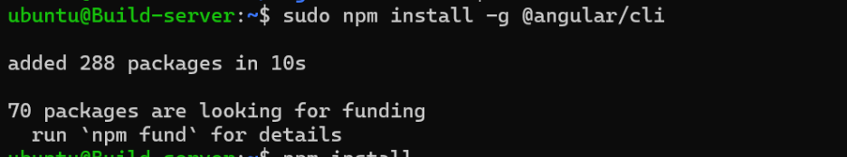

Step 4: Build the Application
The application is built using the build command.
Angular Build
ng build

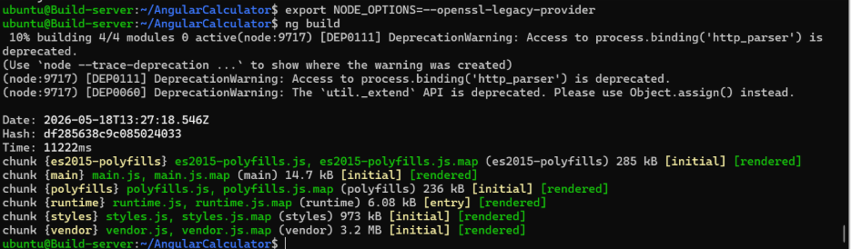

The generated build files are stored inside the dist/ or build/ folder.

Step 5: Create ZIP File of Build
The build output is compressed into a ZIP file for easy transfer and deployment.
Command
zip -r calculator-v1.zip dist/
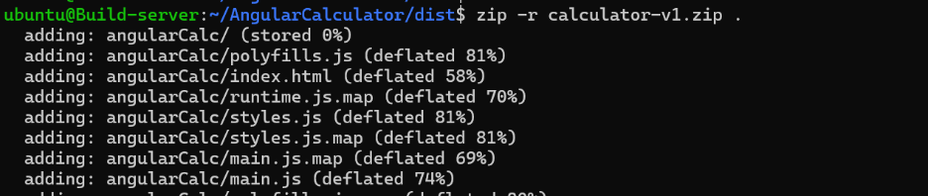

Step 6: Upload Build Artifact to Nexus Repository
The ZIP file is uploaded to Nexus Repository using curl command.
Command
curl -v -u admin:admin123 --upload-file calculator-v1.zip http://3.80.59.36:8081/repository/angular-builds/calculator-v1.zip

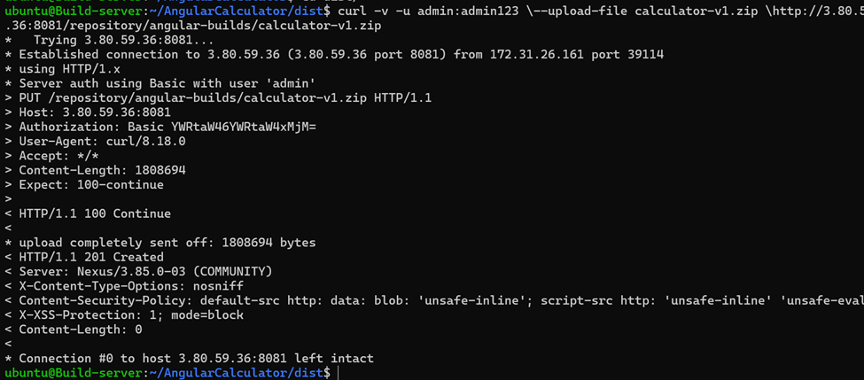

5. Nexus Repository Server Configuration
Install Nexus Repository
Update Packages
sudo apt update
Install Java
sudo apt install openjdk-17-jdk -y
Download Nexus
wget https://download.sonatype.com/nexus/3/latest-unix.zip
Unzip Nexus
Sudo unzip nexus
Start Nexus
cd nexus/bin
./nexus start

Create Repository in Nexus
Inside Nexus UI:
- Login to Nexus
- Go to Settings
- Select Repositories
- Click Create Repository
- Choose hosted repository
- Enter repository name
- Save configuration

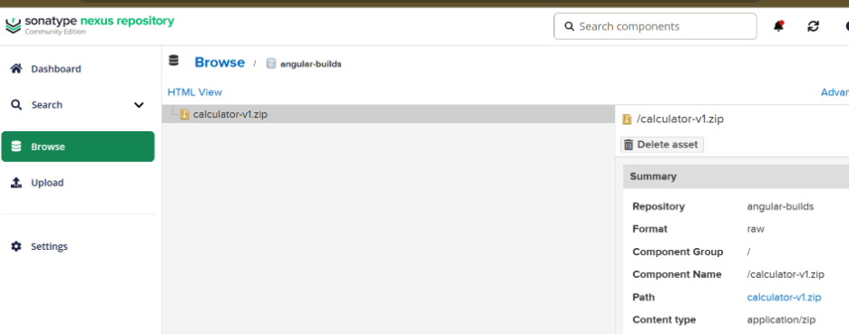

6. Deployment Server Configuration
The Deployment Server downloads the build artifact from Nexus Repository.
Install Required Packages
Install Node.js and NPM
sudo apt update
sudo apt install nodejs npm -y
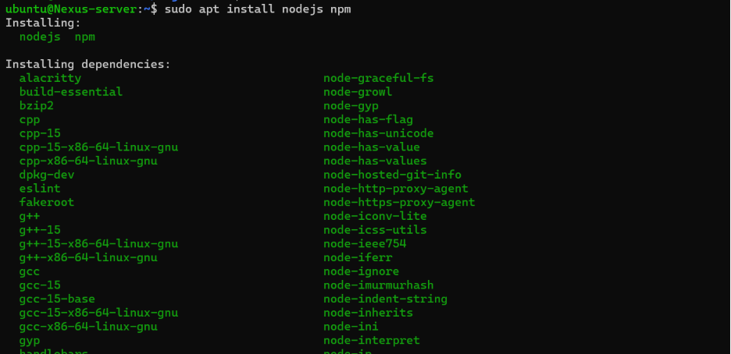

Verify Installation
node -v
npm -v
Download Artifact from Nexus Repository
The deployment server downloads the ZIP file using wget.
Command
wget http://3.80.59.36:8081/repository//application-build.zip

Extract ZIP File
Command
unzip application-build.zip
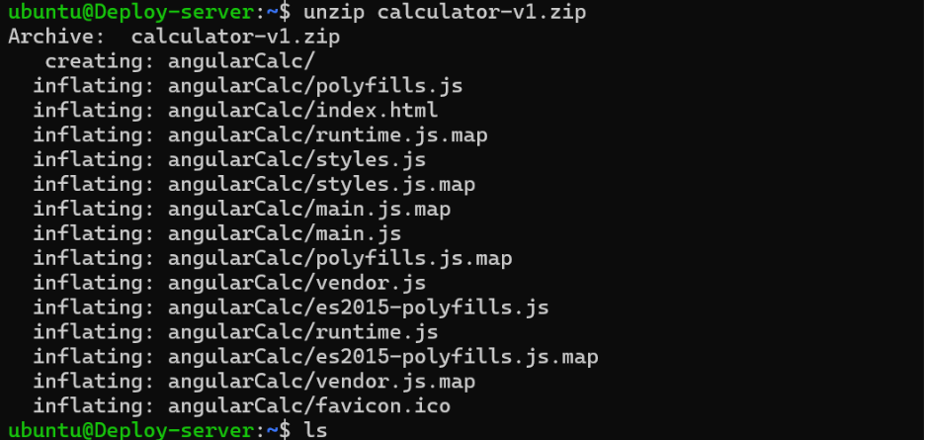

Deploy the Application
Move the extracted files to the deployment directory.
cp -r dist/* /var/www/html/
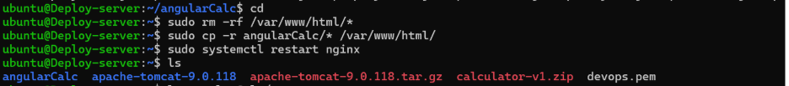

The final Output:
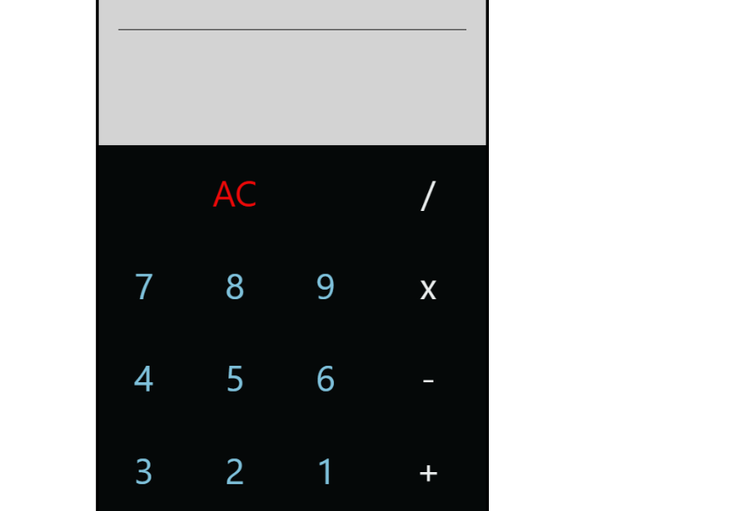

Conclusion :
This project successfully implements a manual three-server architecture using separate servers for building, storing, and deploying the application.
The Build Server handles source code compilation and packaging. The Nexus Repository Server securely stores the generated artifacts. The Deployment Server downloads and deploys the application.
This architecture improves organization, scalability, artifact management, and deployment reliability by separating responsibilities across multiple servers. All operations such as build, upload, download, and deployment are performed manually.

